How to Register for Dr. Adams’s online Class Discussion Group:

- Go to http://www.maryadams.net/classtalk/ and select Register (upper right hand corner) 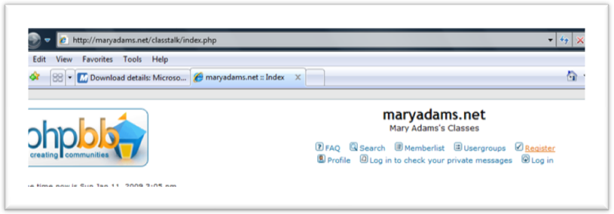
Figure 1: Class discussion board main screen

- Agree to the terms and go to the next screen. Please do not say you are under the age of 18.
- Choose a username that is a lot like your own name (For example, I would select “Mary Adams.”) If I do not recognize your username, I can’t give you credit for attendance and participation. (See figure 2).
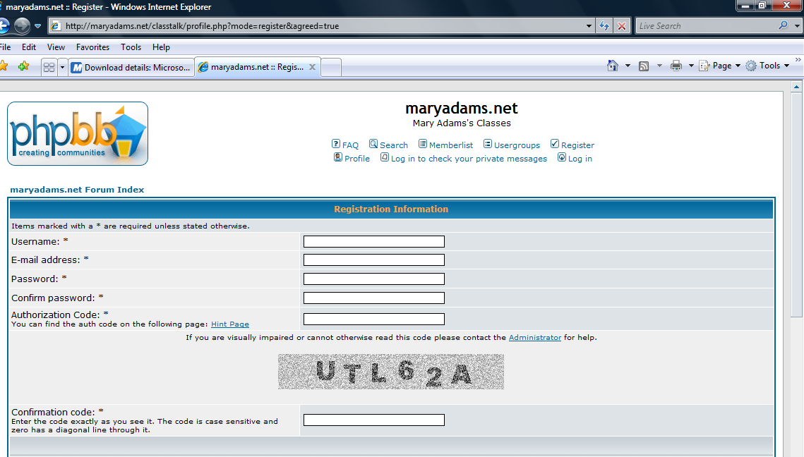
Figure 2: Registration screen (top).
- Fill in the email address and password fields. Make sure you use an address and password you will remember, because you will need these every time you log on. For the confirm password field, retype your password exactly the way you did the first time.
- Type in the board’s authorization code, which is adams98765 (you can go the Hint Page to get a reminder of that). (Note: the authorization code is case sensitive).
- Type in the visual confirmation code. This code will be in a gray box directly above the confirmation code field. (Note: the confirmation code is case sensitive).
- Skip all the rest of the stuff on this page. Scroll to the bottom and select Submit.
You should now be registered on the class message board.

