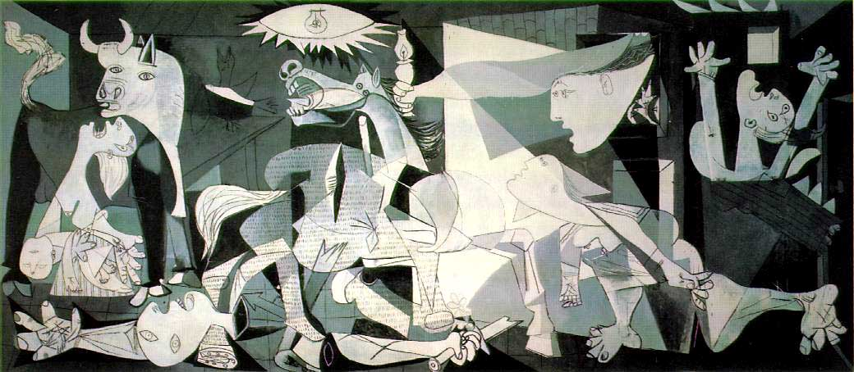

Structure: earth, air, fire, water, 5th element (thunder, aether?)

Wasteland Structure—from Twayne’s Masterworks series by Philip R. Headings

The over-all shape of the poem is an analogous structure having parallels in the Year-god ceremonies; the maiming and eventual healing of the Fisher King; the burial and resurrection of Christ and of the Christian in baptism; the supposed drowning of Ferdinand's father, King Alonso, in Shakespeare's "Tempest," which eventuates in a real psychic resurrection for him; Dante's descent into hell, which eventually leads up through purgatory to the earthly paradise as a prelude to his ascent to paradise; the stealing of the Rhine-gold treasure in Wagner's "Ring of the Nibelungs" tetralogy, eventually returned to its rightful place; and the liberation from lust of Arnaut Daniel's purgation by fire, of Buddha's "Fire Sermon," and of the "Thunder Sermon" from which Eliot takes the three commands Give, Sympathize, and Control.
Each of these involves a death-and-resurrection sequence; each of them, be it noted, implies an awareness of positive potentialities growing out of the initial waste and barren condition.

Voices in the Wasteland

Voices: before being edited by Eliot, this poem was called “He do the Police in Different Voices.” This was a reference to a ventriloquist/ mimic figure, Sloppy, in a Dickens story, Our Mutual Friend, whose could mimic the voices of criminals whose cases were being reported in publications such as the Police Gazette. This lends credence to the idea that these are both many voices and one overarching voice.

- Tradition: the archetypal, historical voice; overarching framework. Female voice: Countess Marie Larisch of Austria. (overlaps with voice of 9 and 18 and 20 and perhaps 4 and 7).
- Wagner’s opera Tristan and Isolde. Isolde is being borne on board ship to a husband she doesn’t love. Her lover, Tristan, cannot come to her because he is wounded.
- Hyacinth girl. Hyacinths symbolize death and resurrection.
- (Male?) speaker in love (?) with the hyacinth girl.
- Madame Sosostris, famous clairvoyant.
- Friend of Stetson.
- Middleton-esque voice: narrates the rape of a woman while her mother is in the next room.
- Vivian, Eliot’s first wife, whom he commits to an asylum. (See movie Tom and Viv).
- Eliot(?) responding to wife in his thoughts. Later, convalescing at Margate, a beach resort, before going to Switzerland.
- Ziegfeld’s Follies of 1912.
- Woman in bar—unkind friend of Lil’s.
- Bartender at last call.
- Crowd in bar.
- Ophelia from Hamlet.
- Wagner maidens and Spenserian maidens: “lovely daughters of the flood.”
- Voice of Parcival from the Grail myth.
- Friend of Mr. Eugenides. Homosexual relationship?
- Tiresias narrating the rape of a secretary by the “young man carbuncular.”
- The Thunder.
- Fisher King
- Children singing London bridge
- Arnaut Daniel in Purgatory (Dante) punished by purifying fire for lust.
- Nerval—french poet who discusses disinherited prince.
- Hieronymo is Kyd’s Spanish Tragedy. Hieronymo feigns madness, kills son’s murderers, and then self.
Dominant Themes:
- Fisher King myth (fertility god who dies and through resurrection renews the land—see Frazer’s Golden Bough, folk tale collection that was highly influential to modernists. Folklorists, like structuralists, etymologists, and Jungians, tried to find the Ur-structures, roots, and myths in the “collective unconscious” which if properly interpreted could unlock all knowledge. Yeats calls this collective unconscious Spiritus Mundi, and Emerson calls it the Oversoul.
- Grail myth. Medieval Arthurian idea that the quest for eternal life (grail) could only be completed by one who was chaste and pure at heart.
- Purification by ritual, quest, fire, drowning, baptism—Purgatory, Tempest references, rebirth.
Secondary themes and motifs (conveyed through voices and allusions) :
- Rape, dismemberment, infidelity, random homosexual trysts.
- Ruin, decay, sterility.
- Madness.
- Prophecy and prophetic voices.
- Four elements: earth, air, fire, water, plus a fifth element or “quintessence.”
- Denial of passions (Buddha) leads to peace.
Total effect of assemblage of fragments:
- Collage—see Guernica. Evokes sense of ruin.
- Supports Eliot’s idea in Tradition and the Individual Talent :
No poet, no artist of any art, has his complete meaning alone. His significance, his appreciation is the appreciation of his relation to the dead poets and artists. You cannot value him alone; you must set him, for contrast and comparison, among the dead. . . . what happens when a new work of art is created is something that happens simultaneously to all the works of art which preceded it. The existing monuments form an ideal order among themselves, which is modified by the introduction of the new (the really new) work of art among them. . . . . The poet must be very conscious of the main current, which does not at all flow invariably through the most distinguished reputations. He must be quite aware of the obvious fact that art never improves, but that the material of art is never quite the same. He must be aware that the mind of Europe—the mind of his own country—a mind which he learns in time to be much more important than his own private mind—is a mind which changes, and that this change is a development which abandons nothing en route, which does not superannuate either Shakespeare, or Homer, or the rock drawing of the Magdalenian draughtsmen.

