To turn of initial capitalization in Word:

- Select Tools, then Options
- Select Spelling and Grammar, then click on
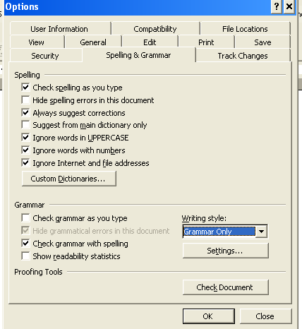
- Select “Settings” under grammar style.
- Unclick capitalization under grammar.

Titles:
Archeology and the Bible
Her Battle
Cinderella
Empire of Dreams
Obit
Birth of Love
Styx
Rules of Sleep
Prisoners
Men at Forty
The Rescue
Voices from the Other World
Why I am not a Painter
Her Kind
The City Limits
For a Coming Extinction
After Making Love We Hear Footsteps
Planetarium
Homage to Paul Cezanne
Dear Utopia
Supernatural Love
Parsley

