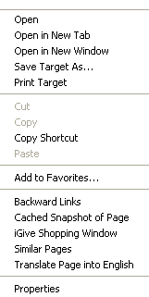
To save sound effect files (.wav) files

- Create a folder on your thumb drive called “My Sound Effects.”
- Use Windows Explorer (not Firefox) to browse to one of the sound effects pages I put on the class syllabus for Thursday, July 19.
- When you find a link to a sound file (for example, scream.wav), right-click on your mouse to bring up the menu (see Figure 1). Select “Save Target As…” and save the file onto your thumb drive. (Make sure you don’t save it on the hard drive).
Figure 1: Select Save Target As

To Put Sound Effects in your PowerPoint demonstration

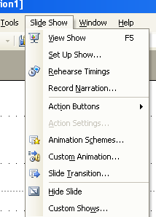
- Select the “Slideshow” menu and then select the “Slide Transition” option. (See figure 2)

Figure 2: Select "Side Transition"

- From the Slide Transition menu at right, look for “Modify Transition,” which is halfway down the page on the right. For “Sound,” select “Other Sound.” When you do, a pop-up window will open to allow you to browse for a sound file. Locate the file in your Sound Effects folder on your thumb drive, and select it. (See figure 3).
  - You can select “Loop Until Next Sound” if you want the sound to play continuously.
  - On the same Slide Transition menu, at the bottom, you can select “apply to all slides” to have the sound effect recur on every slide. If you don’t, the sound will only play on the current slide.
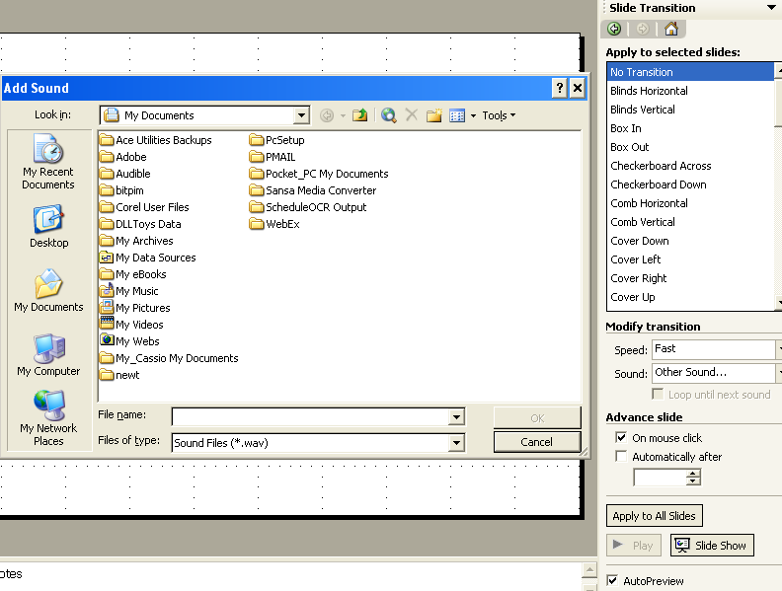
Figure 3: Slide Transition menu

